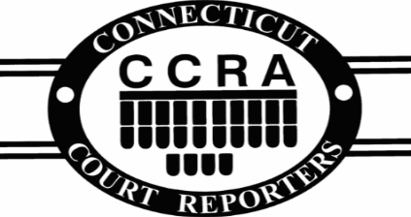
P.O. Box 784
Winsted, CT 06098

WE NEED YOU! Please support the CCRA
2023 Application for membership and voluntary CSR certification

- Name: _______________________________________________________

- Address: _____________________________________________________

- City: ___________________________ State: _________ Zip: __________

- CSR# (Former LSR#) ___________________________________________

- Phone Number: _______________________________________________

- Email: ________________________________________________________

- Voluntary donation: ___________________________________________

- Certifications: Check All That Apply
RPR RMR RDR CRR CRC CLVS Other ________________________

Membership Fee $125. Please make checks payable to:
CCRA, P.O. Box 784, Winsted, CT 06098
OR
Renew online at: courtreportersct.org
Thank you for your continued support!
Please email us if you would like to be removed from our mailing list.
Going Green: Please contact us by email if you would like a printed certificate.

